District Leadership Team 2024-25

District Governor  Mark Odland  M: 269 369 6984  markodland@msn.com  South Haven | 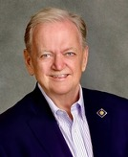 | District Governor-Elect  Jacqueline Kaye Huie (Jackie)  M: 269-930-1325  JackieHuie.Rotary@gmail.com  St. Joseph & Benton Harbor | 
District Governor -Nominee  Timothy A. Lee (Tim)  M: 317-502-9634  timlee0910@aol.com  Sturgis | 
Rotary Foundation (TRF)  Kathryn A. Gallagher (Kathy)  M: 269 209-5949  kgallagher@bcacs.org  Battle Creek |  | Membership Chair  Michael C. Gallagher (Mike)  M: 269-209-1566  mgallagher@gallagheruniform.comGull Lake Area | 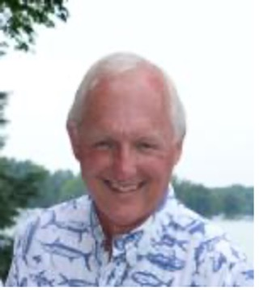
Public Image Chair  Nancy Peterson  M: 269-207-8615  nancylynnpeterson@att.net  Kalamazoo | 

